1. Read the question and the student’s answer carefully.
2. Use the mark scheme to award the student a number of marks and annotate their answer with suggestions to improve.
Stretch: Rewrite the answer to show how it should be done!

Question:
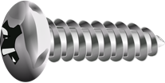
A student wants to compare the density of two objects.
Describe the method(s) that the student could use to measure the density of each object.
(6)

Student answer:

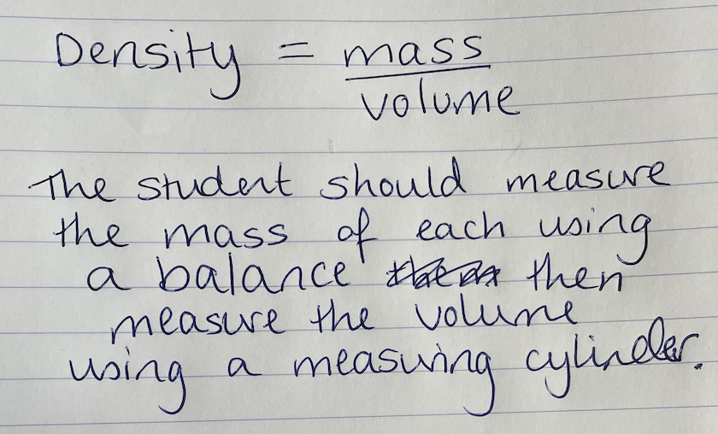

Marks awarded= _______
Mark scheme:
Level 0 (0 marks) | No relevant content
Level 1 (1-2 marks) | Basic descriptions of the measurements that should be taken for one method but no mention of how to use them, or descriptions of the quantities needed to calculate density but no information on how to measure them.
Level 2 (3-4 marks) | Clear description of one method to measure density or basic descriptions of both methods
Level 3 (5-6 marks) | Clear descriptions of both methods that would allow the density of each to be measured

For both
- Measure mass using a balance
- Calculate density using $ρ= \frac{m}{V}$

Cube (regularly shaped solid)
- Measure length of sides using a ruler
- Calculate volume using $lbh$

Screw (irregularly shaped solid)
- Use a displacement can/Eureka can
- Measure the volume of water displaced
- Volume of water displaced = volume of screw

